The Great Divide: A Survey of Women in Art and Craft
by Alissa Guzman on September 28, 2015

Pathmakers: Women in Art, Craft and Design, Midcentury and Today is a brave exhibition currently on view at the Museum of Arts and Design. The show focuses on the overlooked impact of female artists working with materials typically associated with craft or the decorative arts, beginning with historical works from the 1950s and ending with artists as relevant and contemporary as Michelle Grabner. Organized by guest curators Jennifer Scanlan and Ezra Shales, Pathmakers offers a comprehensive look at the key women who laid the foundation for subsequent generations of artists working with “feminine” materials. They were women who helped redefine and recontextualize ways of making that were dismissed by the mainstream of modern art. From weaving, sewing, and quilting to creating functional and wearable pieces, these artists recast the narrative of their materials and gave conceptual integrity to a different way of making.

Though too many of the artists in Pathmakers seem to be included simply because they can fit into the framework of the exhibition, important groups and movements still emerge — most notably, a significant group of fiber artists, from pivotal figures like Sheila Hicks and Lenore Tawney to the contemporary artists who’ve followed in their wake: Polly Apfelbaum, Anne Wilson, Michelle Grabner. Both Hicks’s and Tawney’s practices are undeniably rooted in traditional craft, but they also experimented with shape and form, turning traditional textiles into sculptural installations. Tawney exposed the warp and weft as devices for sculpting rather than fabric making, while Hicks embraced weight and dimensionality with her textile installations in a manner later adopted by artists as diverse as Robert Morris and Ernesto Neto.

Moving from the mid-20th century to the contemporary, a massive installation by Polly Apfelbaum, consisting of 30 hanging textiles covered in geometric drawings, evokes a childlike feeling and blends silk and markers with an irreverent formalism. Is it drawing, painting, or craft? Across the floor, on a series of low, pedestal-like tabletops, Michelle Grabner’s paper weavings are about the process of creating a single structure from a series of disparate parts. Almost luddite in construction and reminiscent of the obsolete technology of punch cards (which Apfelbaum actually used as a stencil for the aforementioned hangings), the works have a digitized tension that adds to their simplistic materiality. Anne Wilson, in stark contrast, represents the slickness of postmodernism, making artworks free of sentiment while dealing with the metaphorical implications of weaving. In her video “Wind-Up: Walking the Warp” (2010), dancers glide around an oversized warping board, placing single strands of yarn onto pegs, one thread at a time. Documenting the creation of a three-dimensional sculpture, Wilson’s video addresses labor, repetition, and touch while also asking difficult questions about gender and value, domesticity and art, craft and concept.

Looking beyond the traditional divide between art and craft while viewing this exhibition can be liberating, as it almost makes it easier to appreciate the diversity of the artists on view. From the highly decorative to the obscurely conceptual, Pathmakers winds its way through decoration and function, showcasing the work of artists who have often been stifled by the misperceptions that surround their materiality. Looking from Ruth Asawa and Eva Hesse to the obscure Scandinavian ceramicist Rut Bryk, it’s the tension between what we value as art and what we consider craft that brings these works to life. Asawa’s crocheted, suspended forms bridge the gap between fiber and sculpture, and her curvaceous and delicate shapes reference both the female figure and the intricacy of her process; her choice of copper, steel, and brass wire, however, suggests that her intentions were more subversive. Hesse, one of the few women allowed into the Minimalist canon, is represented by a sculptural study from the 1960s, and Rut Bryk’s ceramic wall pieces from the ’70s vacillate, like so many others in the show, between the decorative and the conceptual.

Just as photographers fought a long, hard battle in the 1970s to have their work recognized as fine art, these women sought to give a like status to their output. This was and remains a worthy goal, but the problem of the exhibition lies in the reality that its subject matter spans a fault line that is restless — subject to a multiplicity of opinions that constantly move and shift, as new artists and generations partake in the conversation. Unlike many survey exhibitions, there is nothing static here. Yet with a dated feel to much of the work, Pathmakers ends up fighting itself as much as it does sexism, hierarchy, and even art history. The exhibition feels at times as though it’s simply defending against the stereotypes of craft, rather than repositioning the artwork and artists on view.

The survey it attempts, however, is a necessary one: it reminds us that while on the surface art-making today is less restricted by materials deemed worthy, when we dig deeper these limitations still permeate the deepest levels of our understanding. This 21st-century reality makes the exhibition irrefutably relevant, even as the artwork within it leads us to believe otherwise. While the debate between art and craft is as confusing as it is contradictory, it acts as a mirror for the continued prejudices and distinctions made in art history, theory, and practice. Pathmakers’ greatest strength is its ability to remind us of the continual rejection of art that looks and feels too “feminine,” and how easy it has been to dismiss these works of art in the name of craft.

Pathmakers: Women in Art, Craft and Design, Midcentury and Today continues at the Museum of Arts and Design (2 Columbus Circle, Manhattan) through September 30.

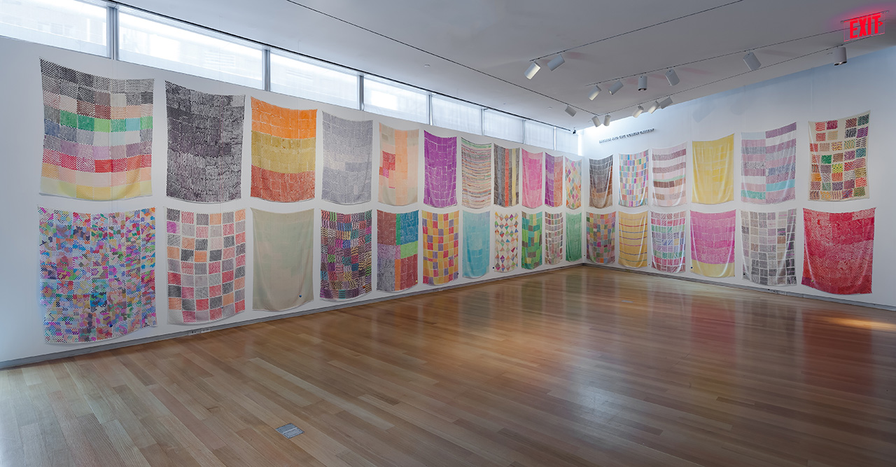
Polly Apfelbaum, ‘Handweavers Pattern Book’ installation (2014), textiles: marker on rayon silk velvet; ceramic beads on embroidery thread (photo by Andres Ramirez courtesy the artist and Clifton Benevento)

